**CoStar Information Collection**

<http://www.costar.com>

Please use the following username and PW to login

Username: SDong2

PW: 719111719111

After you login in, please choose Properties - Multifamily

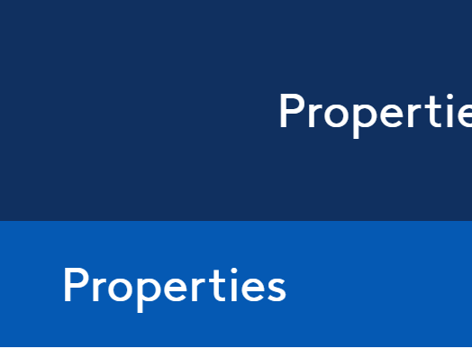

And then please select the “Filters” button. And then please enter the following information on the filters page:

* # of Units: on the tab bar, please choose 50 Units as minimum. I think that excludes some outliers.
* Rent Type: Market. We probably don’t want to include affordable housing.
* Market Segment: Exclude all senior and student housing. The student housing data is a little tricky.

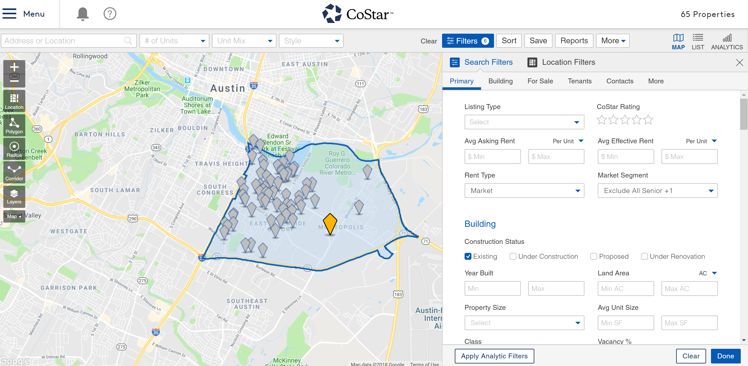

Then if you click “Location Filters” right next to Search Filters, you will be directed to the following page. We can specify the market (Austin) and zip code (78741 for example) as we want.

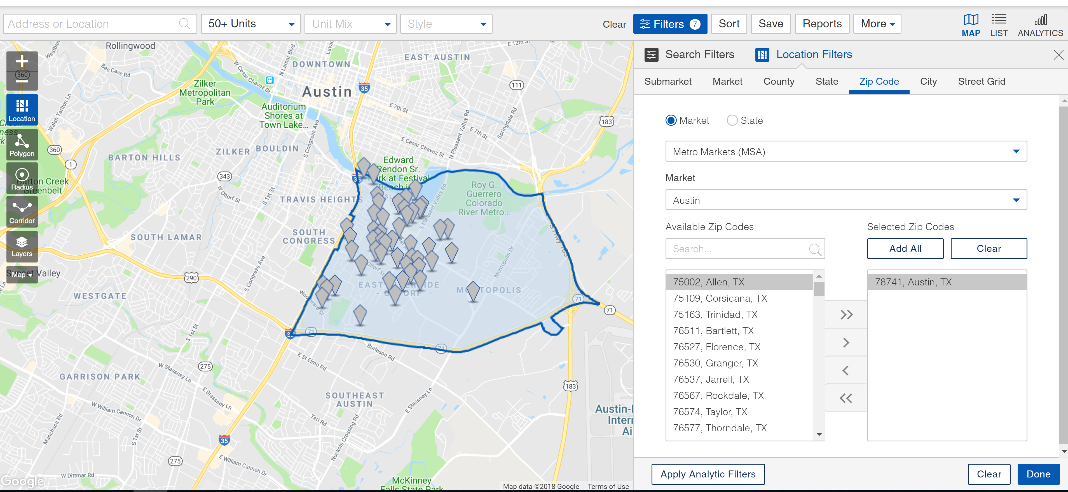

As you finish, you can click “Done” on the bottom right corner. And when you click “List” on the upper right corner, you will get a list of properties that are ready to be exported. You can click “More” and then “Export”. And it will direct you to the following page. Then it is ready to go!

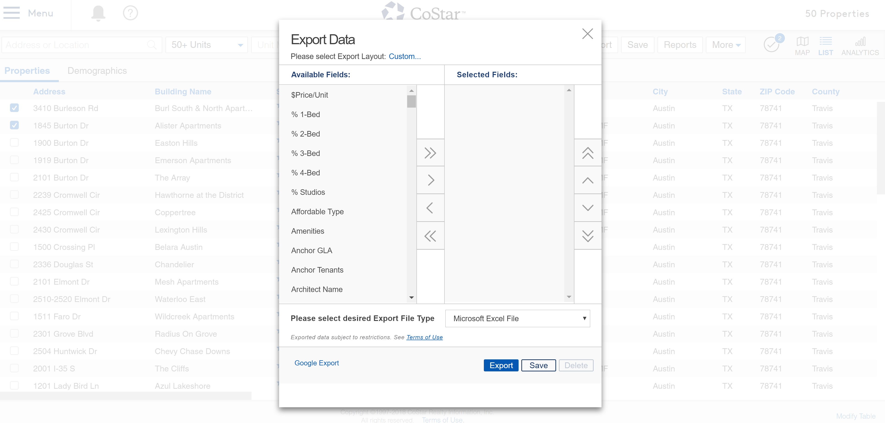

One thing we probably need to spend most time on is the unit mix. We may need to go into each property to get the unit mix information.

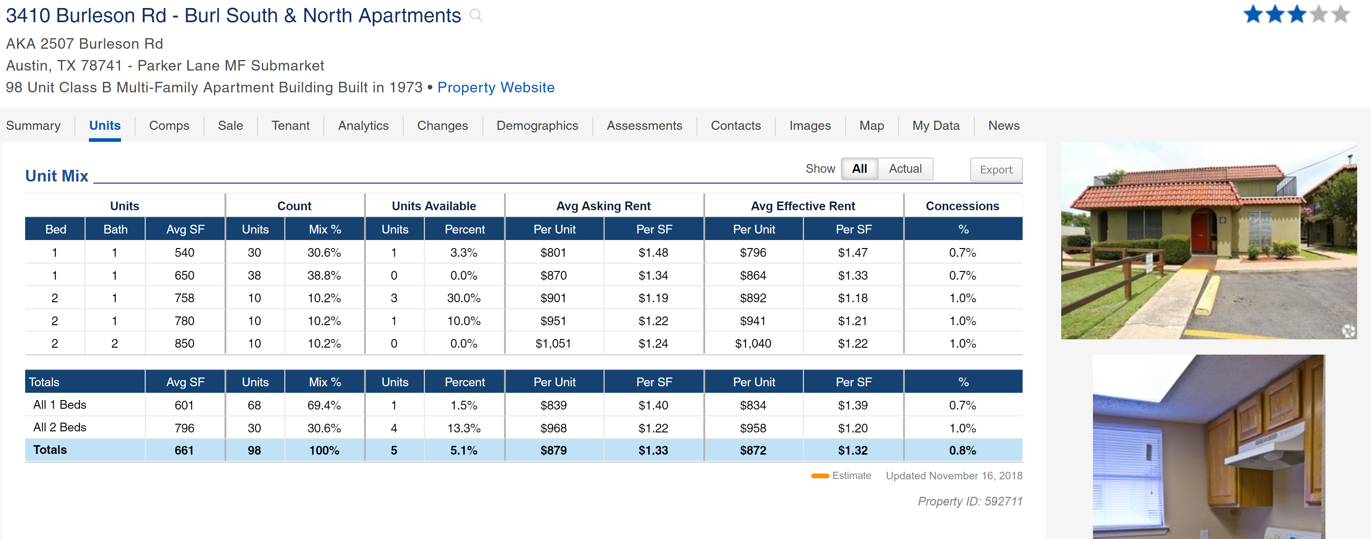

Another tricky thing is regarding the amenities. I view it as a list of column names and we provide answers with only Yes or No.

**Google sheet link:** <https://docs.google.com/spreadsheets/d/1ts3d7aa7zTbvPu-CqgpSxPzJcIO9aI7w4knXk7EuABg/edit?usp=sharing>

Please add new information that you think are important.

Distance calculator by entering two address: <https://www.mapdevelopers.com/distance_from_to.php>